

**SCSV 1213 – WEB PROGRAMMING**

“**DVD RENTAL APPLICATION**”

GROUP PROJECT 2014/2015(2)

GROUP MEMBERS :

* AMIRAH BINTI ADNAN (A14CS0156)
* AMY NATASHA BINTI ABDUL RASHID (A14CS0158)
* LEE GUAN XUAN (A14CS0165)
* YAP YOONG SENG (A14CS0150)

SECTION : 01

LECTURER’S NAME : MADAM NOR ANITA FAIROS BINTI ISMAIL

**INDEX**

|  |  |  |
| --- | --- | --- |
| **Number** | **Title** | **Page Number** |
| 1 | Introduction | 3 |
| 2 | Entity Relationship Datagram (ERD) | 4 |
| 3 | Database (Pangkalan Data) | 5 |
| 4 | Manual   1. Admin 2. User | 6 - 12  13 - 15 |

**INTRODUCTION**

DVD RENTAL SYSTEM adalah sebuah sistem yang dicipta khas untuk penggemar filem. Sistem ini dibangunkan sebagai medium perantara di antara Admin dan User.

Pengguna utama sistem ini ialah Admin dan User. Di dalam sistem ini, terdapat pelbagai fungsi yang boleh digunakan oleh Admin dan juga User. Antaranya, Admin boleh memuat naik filem terbaru dan boleh dipaparkan di laman web tersebut. Manakala User boleh memuat turun filem tersebut dengan log masuk ke dalam sistem.

Sebelum menggunakan sistem ini, User perlu mencipta akaun baru. Dengan adanya akaun, User boleh mula menggunakan sistem tidak kira masa. Sekiranya tidak mempunyai akaun, User perlu mendaftar dengan mengisi boring pendaftaran secara online. User dibenarkan untuk memilih nama pengguna (username) dan juga kata laluan (password) sendiri.

Sistem ini melibatkan beberapa pangkalan data. Pangkalan data digunakan untuk menyimpan data-data berkaitan dnegan sistem. Antara pangkalan data tersebut ialah, senarai filem, maklumat user, senarai user dan filem yang disewa.

**ENTITY RELATIONSHIP DIAGRAM**

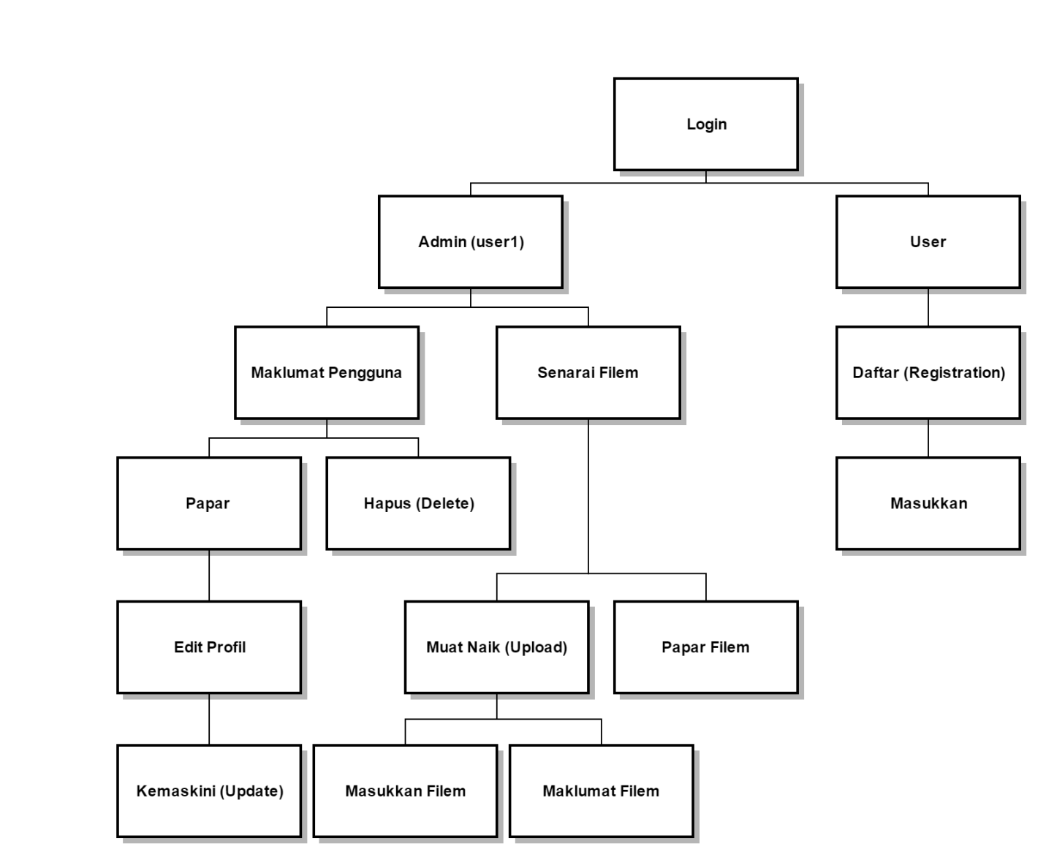

**DATABASE (PANGKALAN DATA)**

Pangkalan Data User

|  |
| --- |
| User |
| id  ic_name  ic_number  email  mobile_number  home_address |

Pangkalan Data Filem

|  |
| --- |
| Movie |
| movie_code  movie_name  movie_image  movie_rating  movie_genre  movie_total |

Pangkalan Data Filem User

|  |
| --- |
| Renter_Movie |
| order_id  movie_code  id |

**MANUAL**

1. Admin
2. Go to http://gmm-fsksm.utm.my/~abta/db_abta

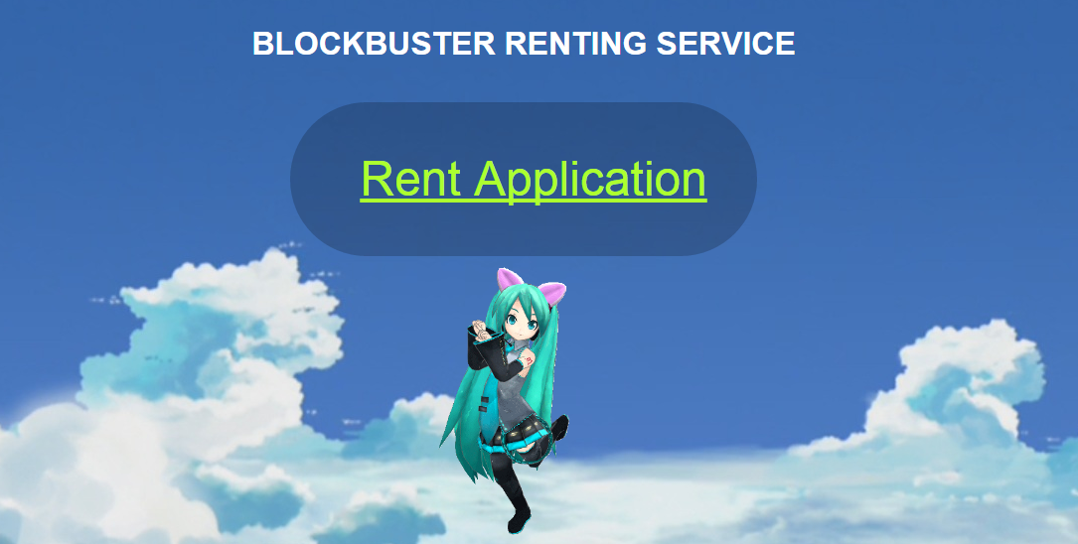

1. Click on the “Rent Application” link. And you’ll get this interface :

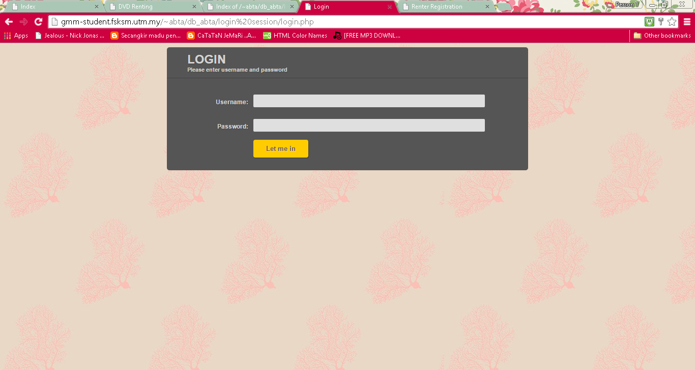

1. Enter the admin’s username and password. For example, we have set the username and password as user1 and user1 on the database. And then you can click on the “Let me in” button. You will get this interface :

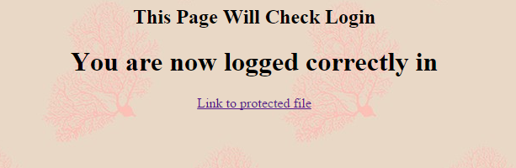

1. Click on the “Link to protected file”. You will get this feature as your interface :

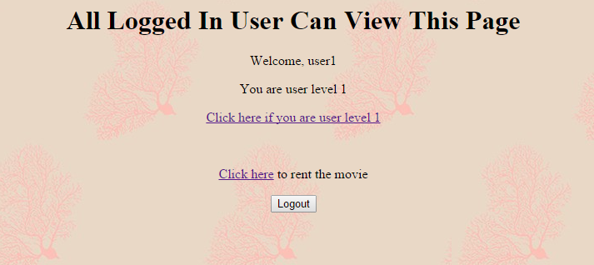

1. Admin is user1 so you can click on the “Click here if you are user level 1”. This link is only visible for the admin. When you click on the link, you will get this interface :

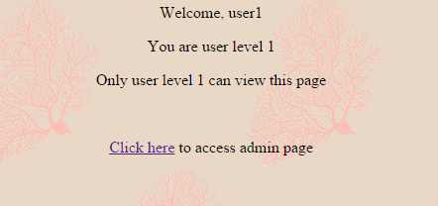

1. Do click on the “Click here” link and you will get this :

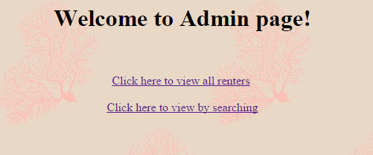

There are 2 options.

1. You can first click on the “Click here to view all renters”. This is the interface :

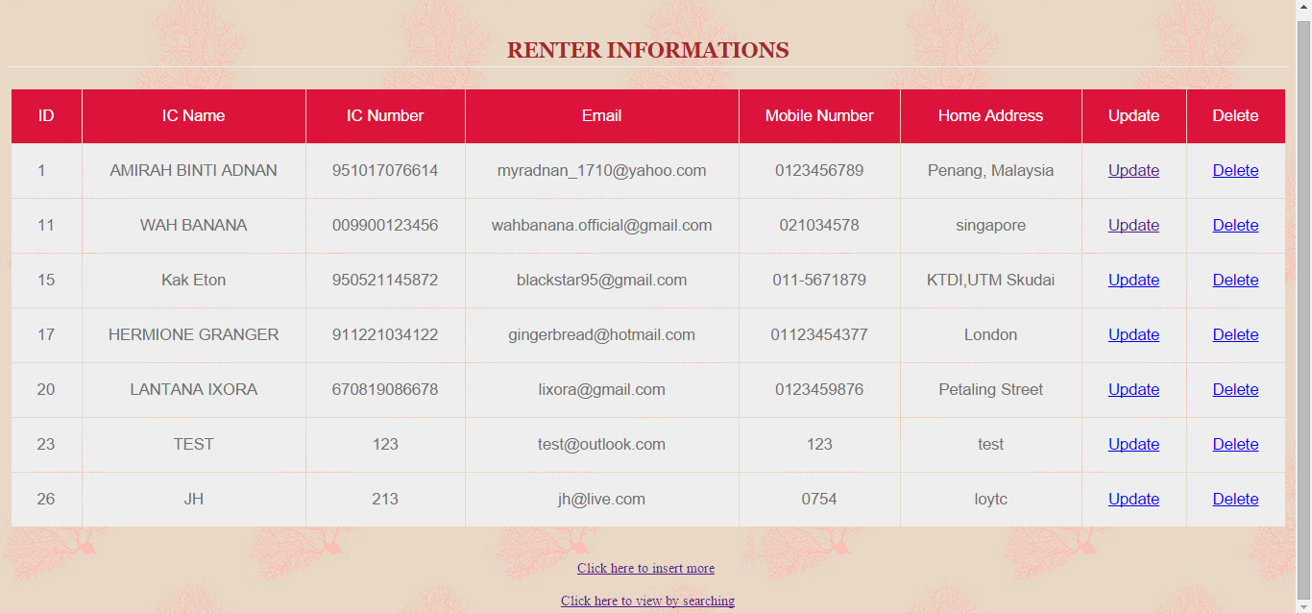

There are the customer’s information also Update and Delete button.

1. If you want to edit the customer’s info, you can click on the Update button and you’ll get to update this form :

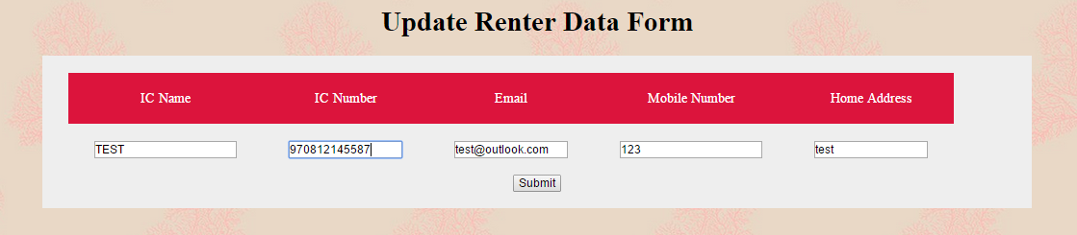

After you finished updating the form, you can click on the Submit button. For example, we have re-edit the customer TEST’s IC Number.

This interface will appear, you can click on the “Click here to list the table”.

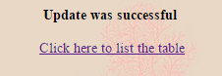

You can see the result here :

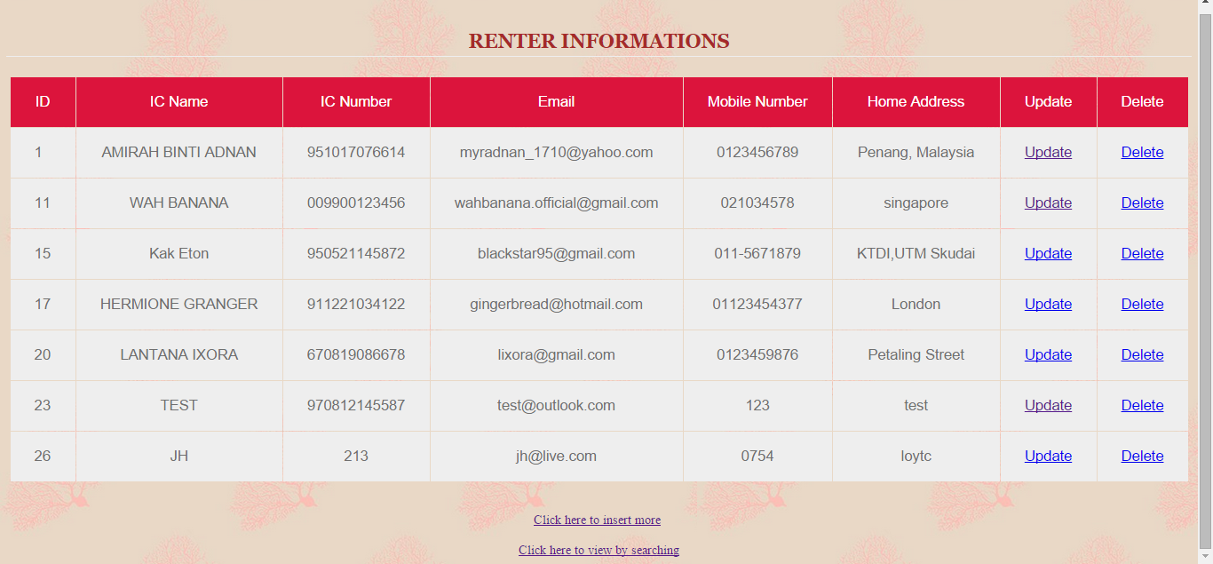

1. You can also click on the Delete button to delete the User’s information.

After you click on the Delete button, you will get this interface :

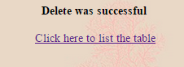

For example,do click on the “Click here to list the table” to check if the User(TEST) information has been deleted or not.

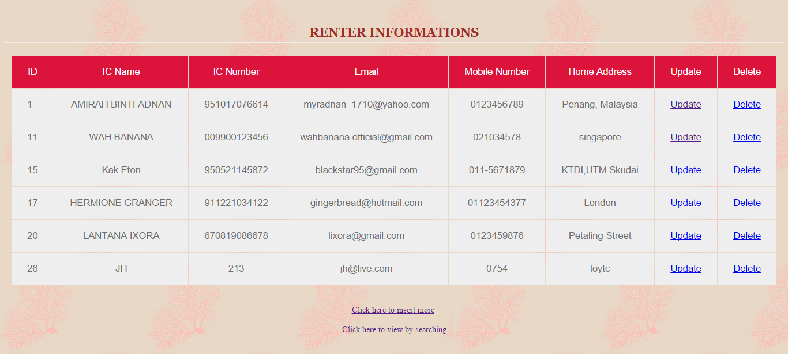

You can see here that User(TEST) has been deleted.

1. You can now click on the “Click here to view by searching”.





And you will get this interface :

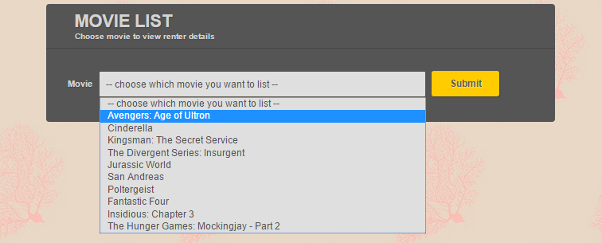

If you click on one of the movies, you will get to view renter that rents the movie.

For example, I will click on the movie “Avengers: Age of Ultron”.

This is the interface :

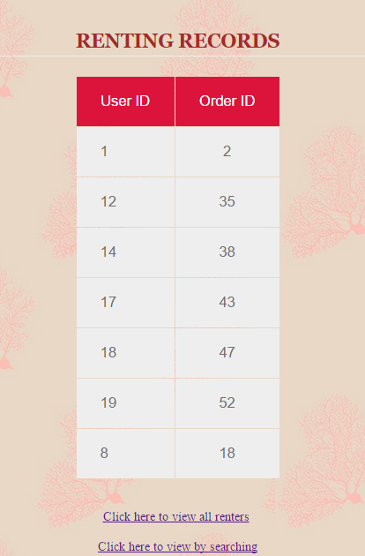

1. User
2. If you already have the username and password, you can straightly log in to the system :

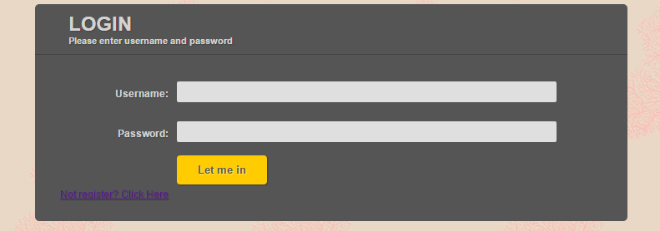

If not you can click on “Not member? Click here” for registration.

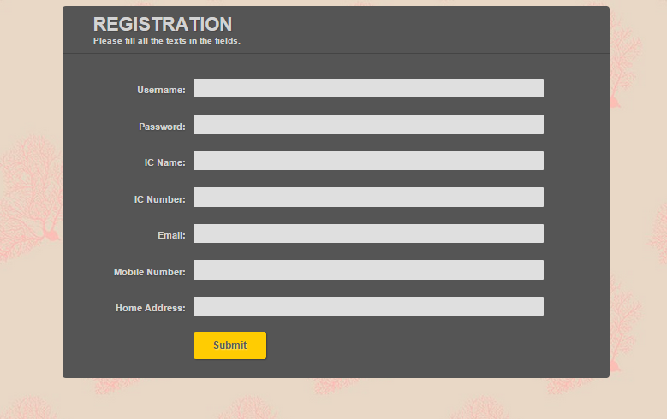

You can fill in the form with your information.

Then, click on the submit button to proceed.

1. If you have registered, you can now log in and you will get this interface :

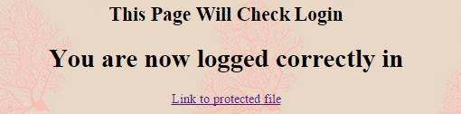

Click on the “Link to protected file” to proceed.

And you will get this interface :

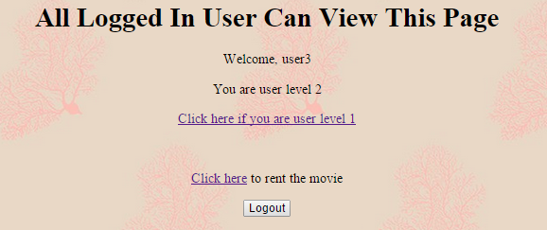

You are now at level 2, as all Users will be place on level 2.

User can never go to level 1.Only admin will be able to go to level 1.

Click on “Click here” to proceed.

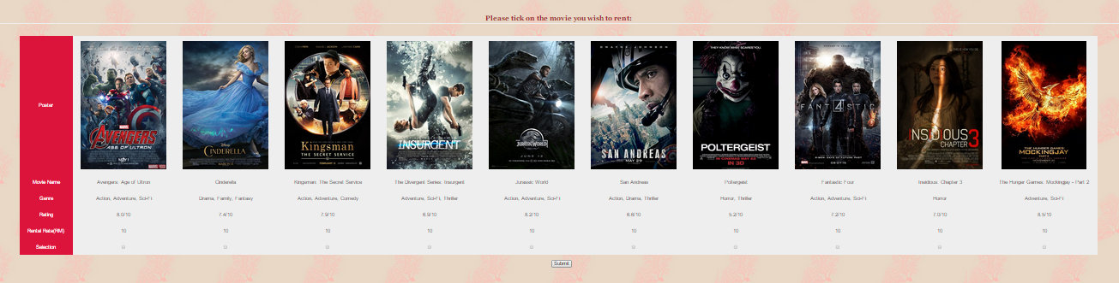

1. The movies information will be shown on the screen.

You can tick on any movie you want to rent.

1. For example, I will tick on Cinderella, Kingsman: The Secret Service and The Divergent Series: Insurgent.

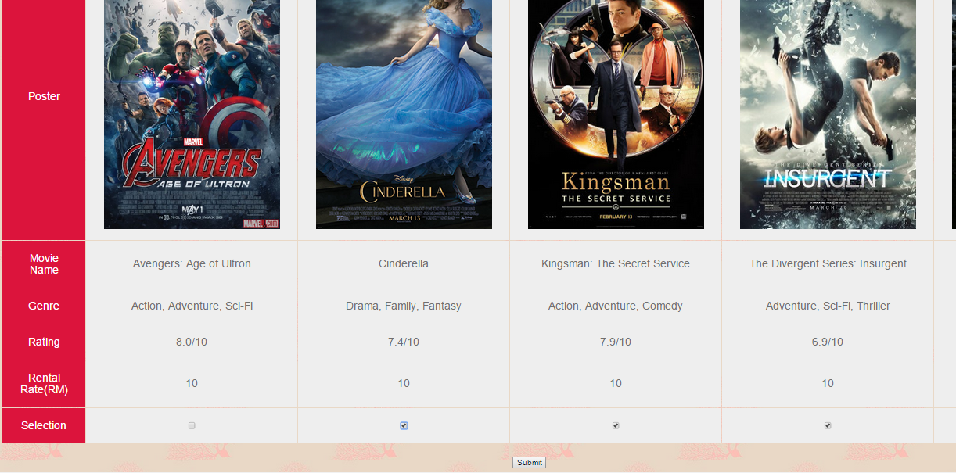

Click on the submit button to proceed.

1. The system will list out the movie(s) you have chosen with the rental price.

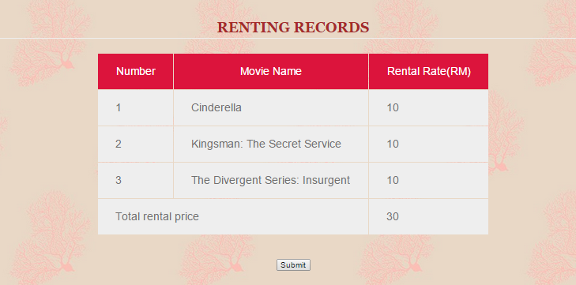

Click on the submit button and you can now enjoy your movie !